Develop an AI-based image-to-image translation system that can automatically transform a real-world photograph into a cartoon-style image while preserving important structural information such as the subject, shape, and overall composition.
Input expected:
Image format: JPG, JPEG, PNG, etc.
Images are resized with (128,128 ,3).
Image pixels are normalized from (0 to 255) to (-1 to 1) before giving it into the generator.
Paired Images with original and cartoon portraits during training.
Expected output:
Cartoon-style representation of the same person while retaining the major facial and structural features
The proposed GAN-based system is expected to perform effective cartoon-to-cartoon image translation while preserving important structures and features of the input image. The use of paired images provides direct supervision, helping the model learn the specific visual transformation required for the project implemented using GAN.
Dataset has been fetched from hugging face which has about 5000 paired real and cartoon images. The purpose of the dataset is to provide paired cartoon images for training and evaluating the proposed GAN-based image-to-image translation system. The paired structure of the dataset makes it appropriate for a conditional GAN (cGAN) approach, as the model can directly compare the generated cartoon image with its corresponding target image during training. In the proposed GAN implementation with paired cartoon images, the target variable is the target cartoon image corresponding to each input cartoon image and the expected output is a cartooned portrait that perfectly blends your original photo content with the target cartoon artistic textures.
Imported required libraries for performing EDA, visualization, creating generator and discriminator model, executing this model and final generated image. Loaded the dataset and performed cleaning and preprocessing like verified duplicates with original and cartoon portraits and also checked for corrupted image. Only the healthy image was passed into preprocessing. Created generator using yield method and it helps to pass one clean NumPy image pair at a time. Resizing single tensors safely without shape conflicts and normalizing to -1 to 1 range and then proceeding with prefetching prepares future batches in the background while the GPU trains the current batch. Images are now all uniformly (128, 128, 3), so batching will never crash and each batch, it will process with 32 images without causing any other issue.
Original image from dataset
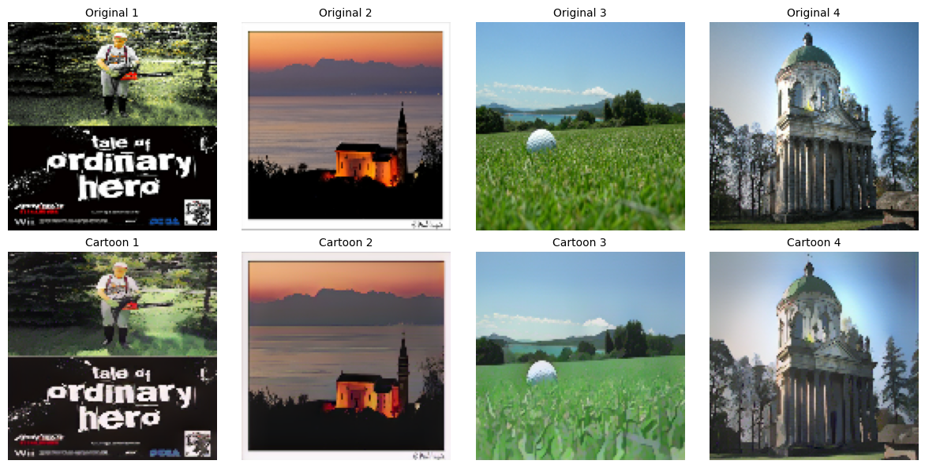
Created generator model using Conv2D helps to extract spatial features such as edges, textures, shapes, corners from grid data images from sliding learnable features across the input data and created discriminator model using 3 layers and it extracts features from scratch and classifies real vs fake patches. Low Level feature mapping to capture Layer 1: Low-Level Features (Edges, Gradients, Lines) Layer 2: Mid-level Geometric shapes and corners, curves Layer 2: Mid-Level Features (Geometric Shapes, Contours, Intersections) Layer 3: TARGET LAYER FOR FEATURE EXTRACTION (Shape: 32, 32, 128) High level semantic features like eyes, noses and also implements Patch GAN Classification Output. Using Adam optimizer and for loss function, used binarycrossentropy. For training method, took the help of Gradient Tape helps to track the record when it’s a forward pass every single operation which happens to its data through the weights and calculate loss score after creating the final image. Then generate the cartoon model using generator model and tricks the discriminator by passing the false label input as 1 for newly generated ones and calculates the generator and discriminator loss for both events and then it processes calculate and apply those gradients using backpropagation with the help of Gradient Tape. calculated image quality and image diversity for understanding the image patch GAN classification output. Now, proceeding with GAN training loop and tracking the metrics as well, printing the loss output for each 50 batches and saving that loss for plotting the metrics visualizations and also saving the epoch image in the below format. 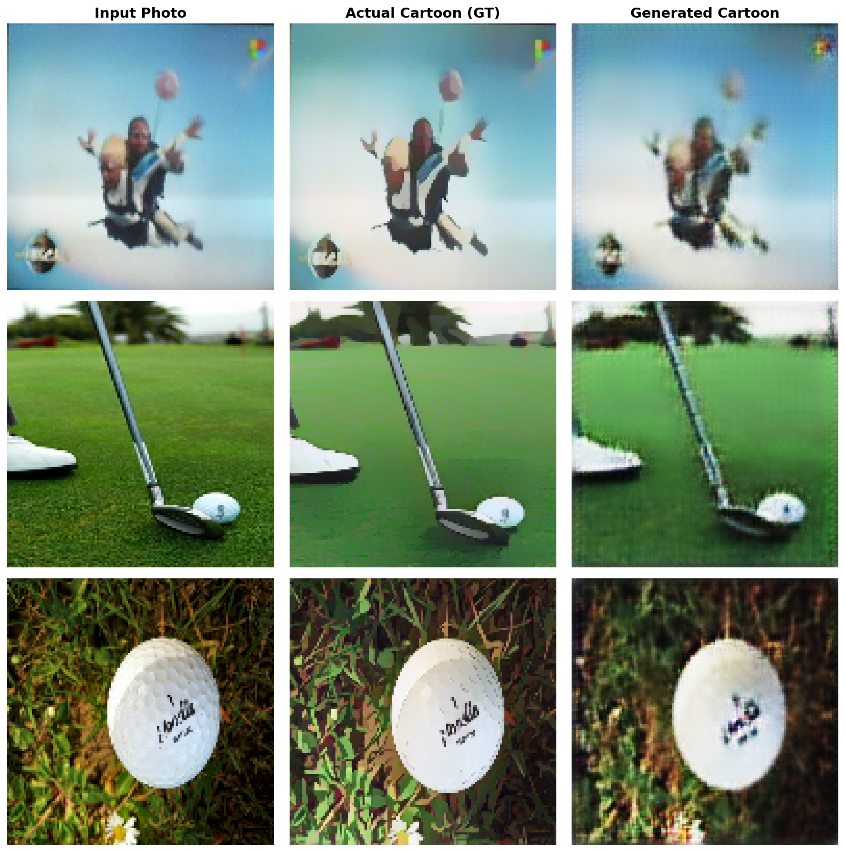

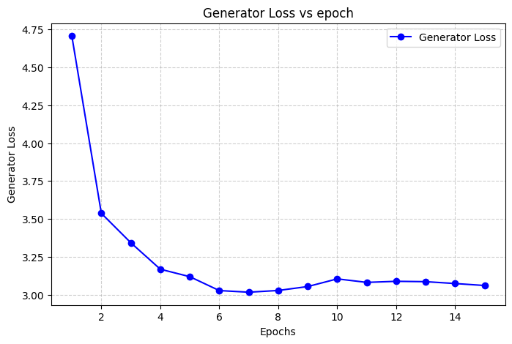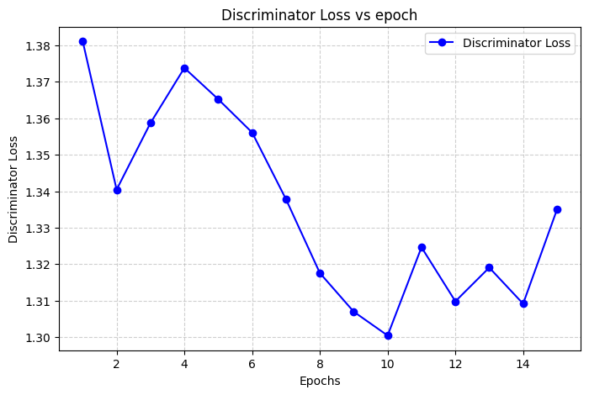

My Discriminator loss is very stable in a standard GAN using binary cross-entropy, the theoretical optimal loss for a perfectly balanced discriminator is 2 times (ln) 2 = 1.38. This happens when the generator becomes so good that the discriminator is entirely confused. The minor ups and downs (especially after epoch 8) are completely normal. They represent the back-and-forth "arms race" between the generator and the discriminator.
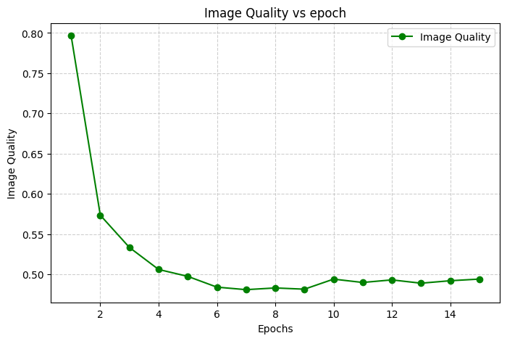
Image Quality->The training dynamics are well-behaved. The fluctuations from epoch 8 to 15 are normal adversarial oscillations, indicating the generator and discriminator are balanced.

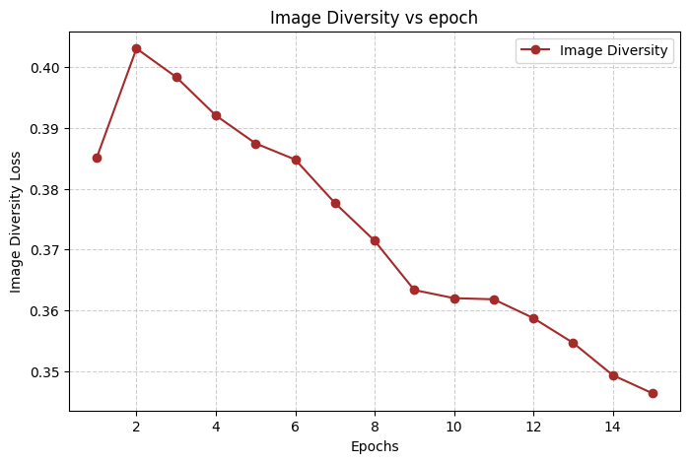
Image Diversity
As we can notice, as the epoch step increase the diversity loss get decreases, it could be a possible indication of mode collapse as it stops finding the diverse textures but just not looking at the metrics alone, we can't derive into a conclusion and also looking at the generated image results, it delivers a better and improvised image for each and every epoch.
Final analysis:
SSIM Metric-> Structural Similarity Index (SSIM)
This helps us to find the similarity check. It focuses purely on structural attributes like overall lighting, sharpness of lights and edges. cartoon image alters the pixel color values from the real photo. while comparing both real and cartoon images, SSIM considers the outlines, shapes, and structural boundaries of the subject and it align spatially ignoring the colors.

Image Diversity->This tells us exactly how generated image looks different from one another within a batch and also, it checks the model work in the intermediate layers. Basically, it checks the colors, textures and brushstrokes which has to be vary from image to image using the metric and if the image looks different from one to another image, then it holds higher variance (this is really creative and also in the correct path) but if the image looks same, then it just does the copy paste job with zero variance (Mode Collapse scenario). This will make the generator lazy because while I pass the image to generator, it generates the cartoon portrait and the discriminator gives the result as 100% Real. then The Generator continue to work with the same look again and again which make the discriminator tricks to be real, as it got passed in first image. This makes the generator to continues with the copy paste job.

